NORTHERN RIVERS ZONE PSSA
NORTH COAST REGIONAL PSSA
CROSS COUNTRY CHAMPIONSHIPS 2024

Congratulations, your son/daughter/ward ....................................................................................has been selected to represent the Northern Rivers Zone PSSA at the North Coast Primary Schools Cross Country Championships.

Date: Friday 21st June 202
Venue: Nana Glen Sport, Recreation and Equestrian Centre

Starting Time: 9am SHARP 9.45am - Walk the course

Travel: Parents/Caregivers are asked to arrange transport, in consultation with their child’s school. No bus transport will be provided.

Team Levy: a. $30 per competitor (which covers the cost of a NR singlet)
or b. $7 per competitor (singlet already purchased from previous years)

Uniform: All competitors MUST wear a Northern Rivers Zone running singlet. Shoes are compulsory. Competitors not complying will not be permitted to run in their event. Singlet can be collected from team managers on the day.

Team Managers: Margie Dixon Amanda van den Berg Kylie Henshall Sam Nilon
Wollongbar PS Dunoon PS The Channon PS Coffee Camp PS
Ph: 6628 1302 Ph: 66895208 PH: 66886236 PH: 6689 9259

Event Summary: These times are used as a guide only. Carnival Management reserves the right to alter these times and the order of events should the need arise.

- The completed Consent Form is to be handed directly to Northern Rivers Team Manager on the day of the NC Cross Country Championships.
- Singlets will be given out at this time.
- Levy and/or singlet payments are to be paid to your school. Schools will be invoiced by NRPSSA in term 3

CROSS COUNTRY RULES:

- Footwear MUST be worn but NO spikes permitted.
- No competitor is to run without footwear.
- No pushing, tripping or interference with other competitors is permitted.
- No competitor is allowed to receive assistance or refreshment from ANY person during the race.
- A competitor may carry his/her own drink or asthma puffer.
- All competitors MUST compete in the NR Zone uniform.
- Competitors must run around the OUTSIDE of markers where a change of direction is indicated.
- A Disputes Committee comprising the Carnival Manager, S.C.O. and any two Zone Managers adjudicate any disputes arising from the Championships.

STATE CARNIVAL: The NSW PSSA Cross Country Championships will be held 23 -24 July 2024 at Sydney International Equestrian Centre.

North Coast Cross Country Championship
Program of Events Attached

Presentations will be made after each event
Times are estimations – please ensure you are ready for your event when called for marshalling.

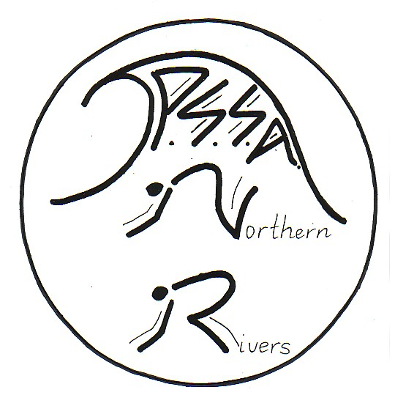

NCPSSA REGIONAL CARNIVAL

REPRESENTATIVE CONSENT FORM

SPORT: NCPSSA Cross Country Championships
DATE/S: Friday 21 June 2024

VENUE: Nana Glen Sport, Recreation and Equestrian Centre

LEVY: $30:00 per student. (Levy and singlet)
$7:00 per student (Levy only)

Consent Form is to be handed to Northern Rivers Team Manager on the day of the Cross-Country Championships. Singlets will be given out at this time. ALL LEVIES MUST BE PAID TO YOUR SCHOOL

Student Details (Please print clearly)

Student Full Name:__________________________________________________________________________

Parents/Caregiver Full Name: _________________________________________________________________

Address: _________________________________________________________________________________

Postcode: __________ Date of Birth: __________________ School: _______________________

Phone: (Home) _____________ (Work) ________________ (Mobile) ____________________

Medical Details

Medicare Number: __________________________Expiry Date: __________________

The date/year of my child’s last tetanus injection was: _____________________________________________

My child is allergic to:_______________________________________________________________________

Please indicate if your child has:

- Asthma YES / NO
- Anaphylaxis YES / NO

If you have indicated YES, a medical plan from a Doctor must be attached to this form. Relevant medication and/or equipment should accompany the student to the sports trials. The Team Manager should be advised of this at the beginning of the trials.

Any medical details or special needs which the team manager might need to know:

_________________________________________________________________________________________

_________________________________________________________________________________________

Medical Insurance: Personal injury statement
In the event of injury, no personal injury insurance cover is provided by the NSW Department of Education for students in relation to school sporting activities, physical education lessons or any other school activity. The Department’s public liability cover is fault-based and limited to breaches by the Department of its duty of care to students that may result in claims for compensation.
For events outside NSW, parents/carers who have private ambulance cover are advised to check that their cover extends to interstate travel.
The NSW Supplementary Sporting Injury Benefits Scheme, funded by the NSW Government, provides limited cover for serious injury resulting in the permanent loss of a prescribed faculty or the loss of use of certain prescribed parts of the body. The Supplementary Scheme does not cover medical costs or dental costs. Further information can be obtained from https://www.icare.nsw.gov.au/injured-or-ill-people/sporting-injuries/payments/#gref

COVID
If you or your child are displaying any symptoms of COVID or other illness, you are NOT to attend this event. It is recommended you seek medical advice and/or seek COVID testing.

Travel Details
My child WILL travel privately to and from the carnival with:_______________________
Relationship to my child: _________________________________
Privacy Notice

The personal information provided on this permission note, will be used by the Department of Education and Training for general administration and communication and other matters of welfare relating to your child at this event. The provision of this information is voluntary but your child may not be able to participate if it is not provided. This information will be stored securely and may be amended at any time by contacting the team management. Please be aware that the media exposure at this event may result in your child’s name, school details and/or photograph appearing in a Newspaper, on Television or on websites including the School Sport Unit website at
https://app.education.nsw.gov.au/sport or www.northernriverspssa.com

If you have a concern with this occurring, please contact the team management or Regional Sport Organiser immediately.

Principal’s Declaration Student: ___________________

- I certify that the student whose details appear on this form is enrolled at this school.
- I have verified that the date of birth as stated on this form is correct.
- He/she has the school authority to represent on this occasion.
- A copy of this consent form will be retained by my school.

SIGNED: ________________________________ _____________________________
(Principal) (Date)

NOTED BY: _________________________________________
(Sports Organiser)
Parental Consent

- I have read the information issued and I hereby consent to my child participating in this event.
- I understand that my child will be under the supervision of Team Manager/s and will not be allowed to visit friends or relatives without my written permission and that of the Team Managers.
- In the event of any accident or illness, I authorise the obtaining, on my behalf, an ambulance and any such medical assistance that my child may require. I accept full responsibility for all expenses incurred.
- To assist team management at the Championships and to the best of my knowledge, my child has no medical condition or injury that places them at risk in participating in this sport activity.
Concussion acknowledgement
- I acknowledge that if my child has sustained a concussion in the lead up to the event, I must provide medical clearance to the school or the supervising teacher prior to competition commencing.
- I understand that if my child sustains a concussion or suspected concussion during an NSW Department of Education sporting event, they will be removed from competition until medical clearance is provided to the supervising teacher.

SIGNED: __________________________________ _____________
(Parent/Guardian) (Date)

TEAM LEVY: Please tick the appropriate boxes

{ } I enclose $30 for the Team Levy (which covers the cost of the NR Zone singlet).
{ } I enclose $7 for the Team Levy (having previously purchased the singlet).

My child’s shirt size is:

{ } 8Y { } 10 Y { } 12 Y { } 14 Y { } 16Y { } S { } M

The uniform will be available from the NR Team Managers on the day of the Carnival.
School Office use only
Payment of the levy has been received from the student and processed by the school. The school will send all levies paid to the school for NRPSSA events to the Northern Rivers PSSA as required in term 3.

Signed: _________________________________ Name: _________________________________ Date: ______________

Amount Paid to school: $____________
Please certify with a school stamp:

Students are unable to participate without Principal approval and having paid the levy to their school.

SCHOOLS need to:

Complete THIS page by listing ALL students attending Regional carnival from your school and email to Margie Dixon

Email: marguritta.dixon1@det.nsw.edu.au
by Wednesday 12th June 2024.

DO NOT FAX STUDENT CONSENT FORMS

School name:

Contact staff member:
Student name: | Event: | Principals Approval to participate | Approximate singlet size
Example:  Peter Bylos | 11 year Boys 3000m | Yes | Y14

