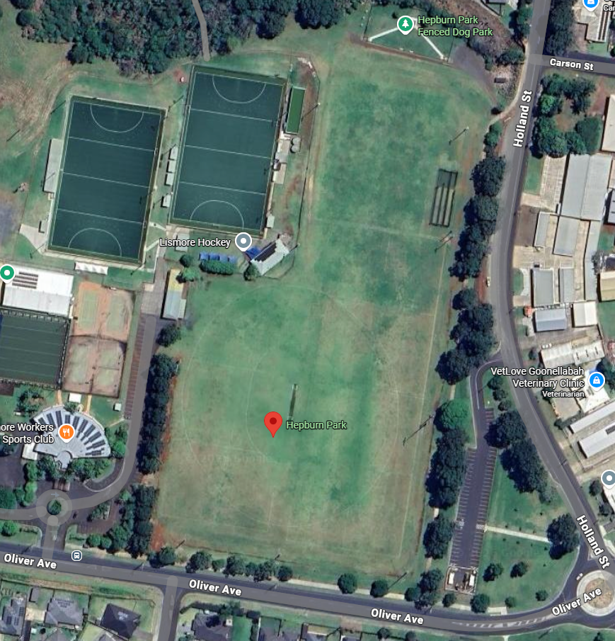
2 & 3
12
11
10
9
8
7
6
5
4
1
Finish Line
Canteen
Recording
Start Line
District Tents

